CSC235 Final Project Report – Dean Wilcox – 19 October – 2023

Hello, welcome to my project utilizing Ansible, Vagrant, bionic64 and the Linux OS on Ubuntu.

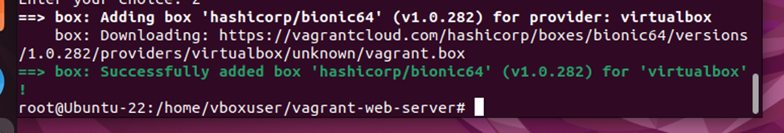

The first thing I did was install Ansible onto my system. I ran into a couple of issues, so I had to outsource info online to get the job done. I used the following websites:

<https://www.howtoforge.com/how-to-install-and-configure-ansible-on-ubuntu-22-04/>

<https://docs.ansible.com/ansible/latest/command_guide/intro_adhoc.html>

<https://docs.ansible.com/ansible/latest/cli/ansible-playbook.html>

Next, I downloaded Vagrant using this website: <https://developer.hashicorp.com/vagrant/downloads>

After that I used [https://subscription.packtpub.com/book/cloud-and-networking/9781786464910/1/ch01lvl1sec10/adding-an-ubuntu-xenial-16-04-lts-vagrant-box to install xenial64](https://subscription.packtpub.com/book/cloud-and-networking/9781786464910/1/ch01lvl1sec10/adding-an-ubuntu-xenial-16-04-lts-vagrant-box%20to%20install%20xenial64)

After all of the above steps were completed, I ran my first ad hoc command “ansible all -m ansible.builtin.setup

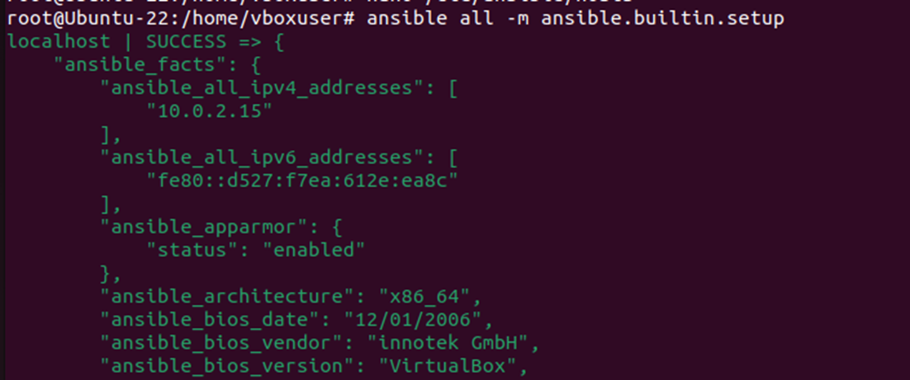

While I was learning this new system, I created a playbook using nano.

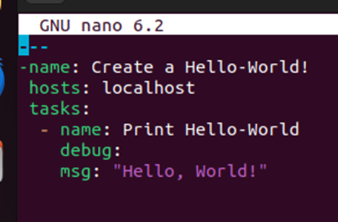

This .yml file is to print “Hello World”, but I am having an issue with the syntax where it won’t run properly. That is something I am currently trying to fix with no luck.

